Texas A&M University

Term Project Proposal: Environmental Sensing-based Object-following – Rover

Term Project

Padmashree Srinivasan (731007503) – Effort: 100%
Arunachalam Venkatachalam (333000500) – Effort: 100 %
Carlos Navarro Naranjo (726003363) – Effort: 100%

Mechatronics-MEEN 667

Dr. Won-Jong Kim

30 November 2022

OBJECTIVE & SIGNIFICANCE:

The main goal of this project is to build an environmental sensing-based object-following
rover. Our main objective can be divided into two main tasks: panning and following an object around.

The Arduino installed on the robot receives two types of input. The first kind comes from an ultrasonic sensor. The sensor is expected to measure the object’s distance using ultrasonic waves. The second input comes from multiple proximity sensors that detect the presence of nearby objects. Both types of sensors are located on top of a 1 Dof pan mechanism that allows for a turning motion. Arduino then produces a motion control output that results in 2 types of movement. The first type is the turning motion that allows for the “head” of our robot to pan the object. This motion is done by using a servo motor that makes the “neck” of our robot turn. The second type of motion is object-following. This motion is controlled by a pair of DC motors via the motor driver. The rover is put into motion when an object is introduced in its sight, otherwise the robot will be in a dead state. The robot’s detection range for both sensing mechanisms goes for a proximity of 20–30 cm and 120 ° degrees of spherical proximity respectively.

This technology could be employed to improve customers’ shopping experience. The same concept can be applied to bigger shopping carts like the ones in grocery stores. The vehicle controller obtains inputs through ultrasonic & proximity sensors and then produces a vehicle control output, such as a steering wheel angle to navigate the vehicle safely in a store environment. The goal is for autonomous shopping carts to follow customers around the stores instead of making the customer push its cart around.

Engineering Drawings:

Components Required:
- DC Motors
- Arduino Mega
- Motor Driver
- Ultrasonic sensor
- Proximity sensors
- Battery
- Chassis + wheels

S.no | Topic | Description
1 | Analog electronics | ADC in Arduino mega – Applied in controlling servo
2 | Digital logic | Pulse Width Modulation (PWM) – to control DC motor
3 | Sensors | Ultrasonic sensor (HC-SR04) and Proximity sensor
4 | Actuators | Servo-motor & DC motor

Table 1

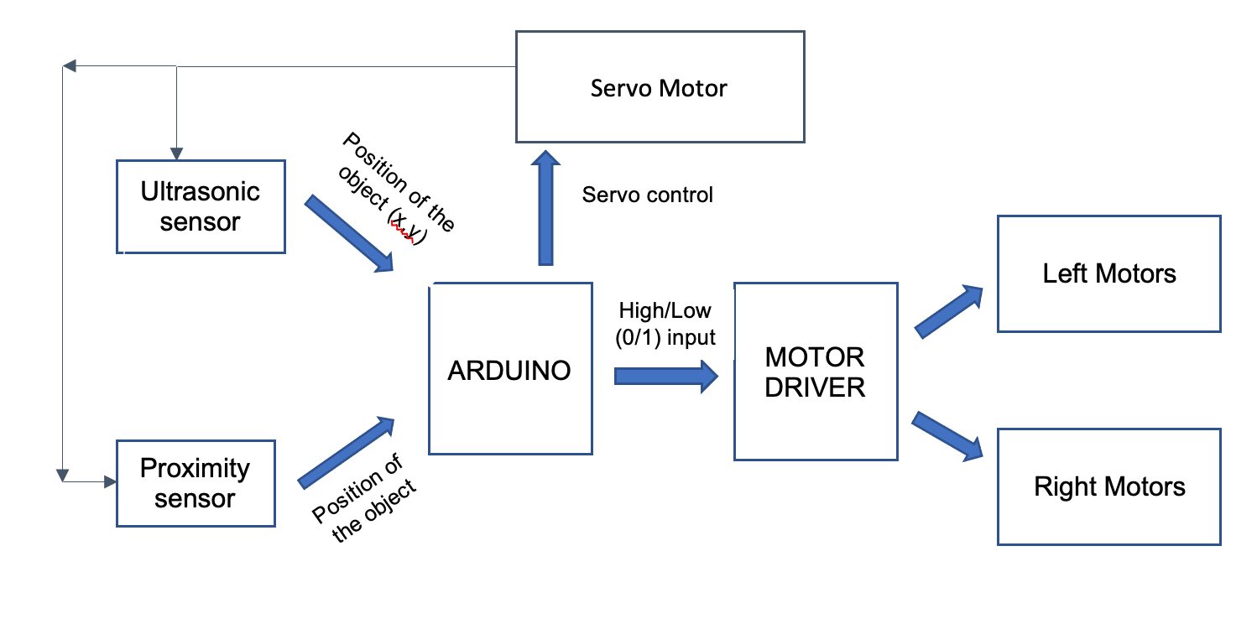

Figure 1

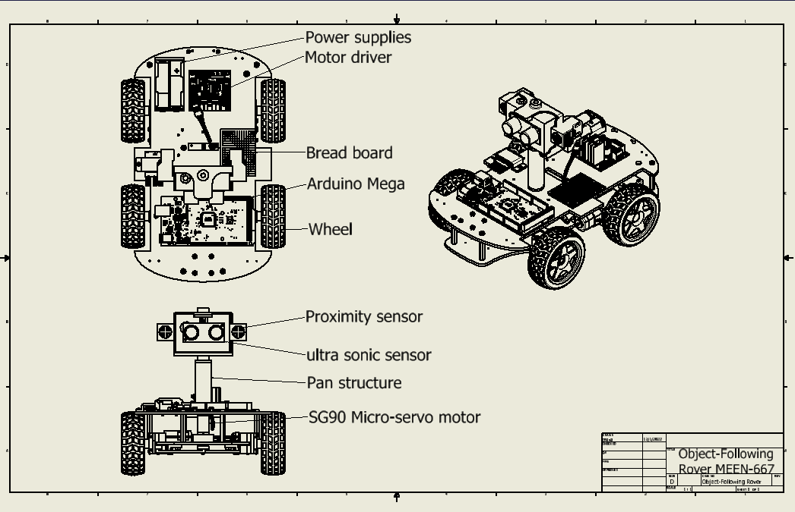

Engineering Drawing 1: Front, top and Isometric Views

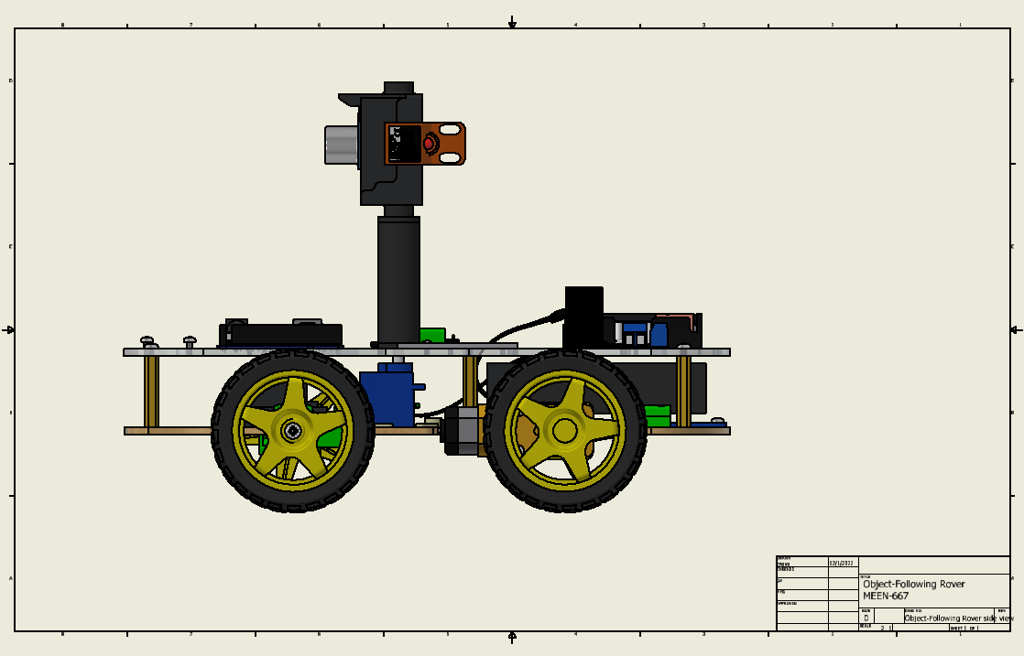

Engineering Drawing 2: Side View-Shaded

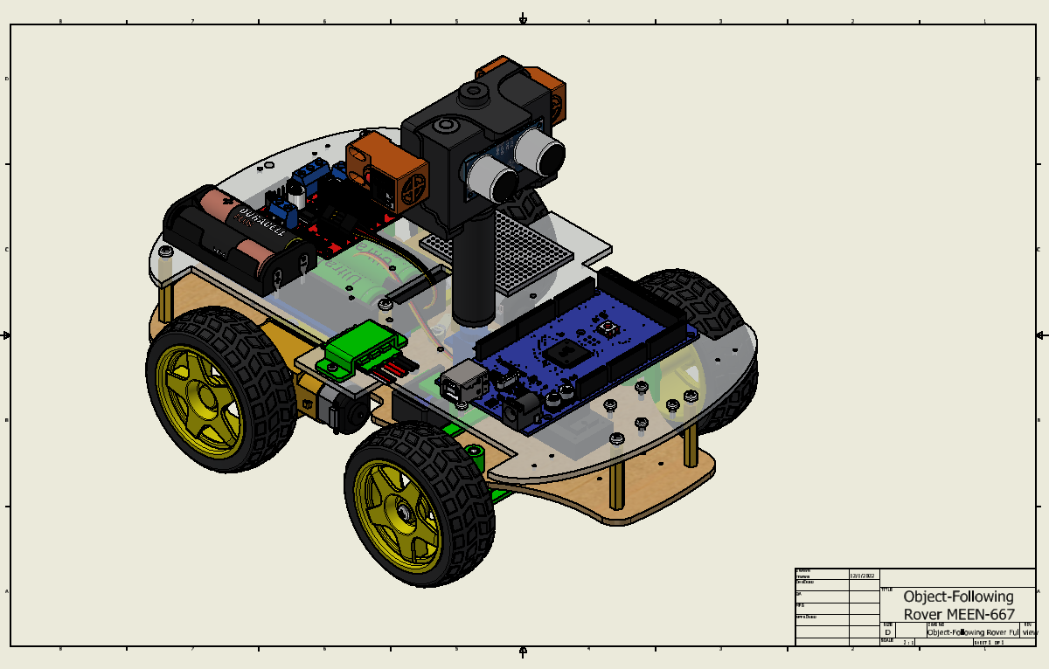

Engineering Drawing 3: Isometric View-Shaded

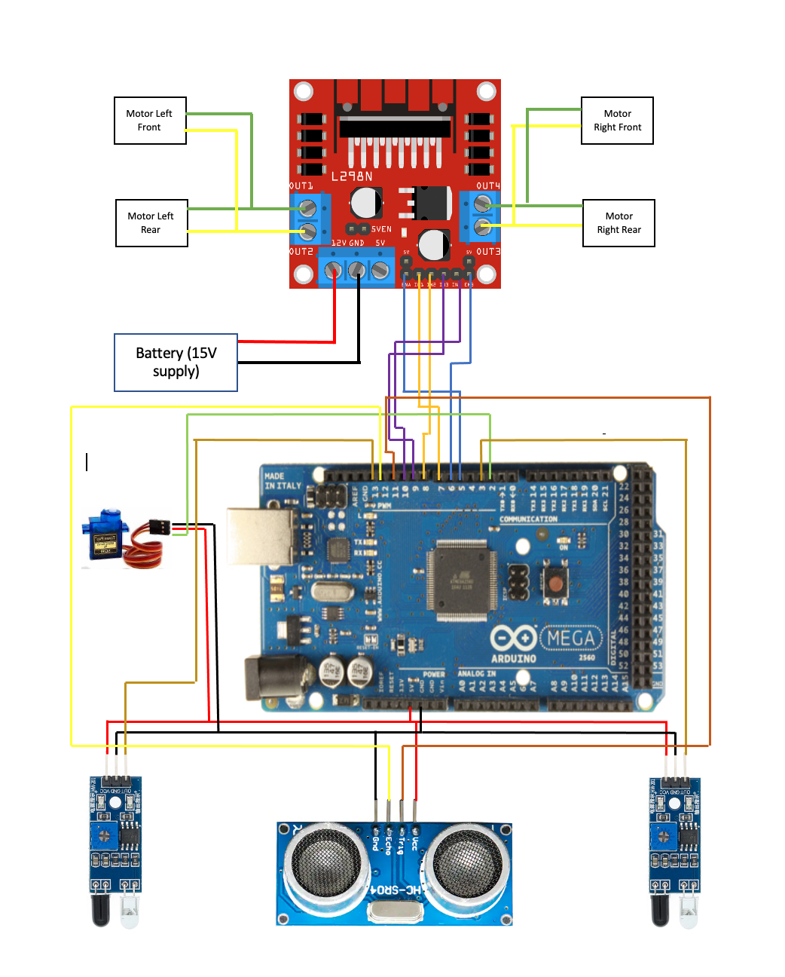

Figure 2: Robots’ Circuit Diagram

Experimental Results:

The rover is expected to be aware of its surroundings and actively look for an object to move without colliding. The rover would move if an object were present and is detected by the combination of proximity and ultrasonic sensors, else it would stay at the same position.

In order to prevent the rover colliding with the object, a constant distance of 10cm is maintained between the object and the rover. When the object is closer to the

We expect the rover to be pretty accurate since using the Bluetooth module for voice command is proven to be very effective in short ranges. We will be communicating the voice command to the rover using an android application which ensures precision and accuracy. We expect this rover to have a good performance once the project is complete.

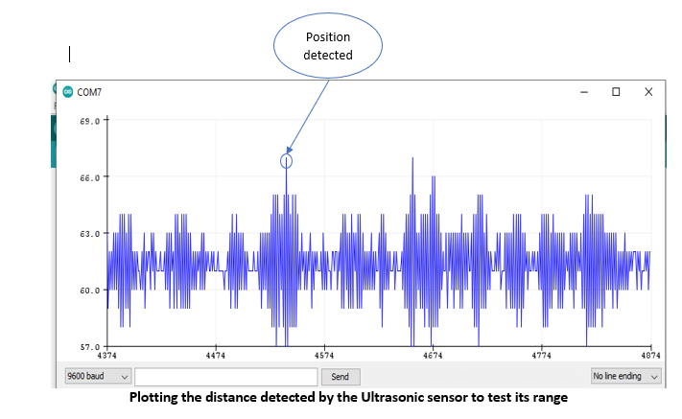
Figure 3

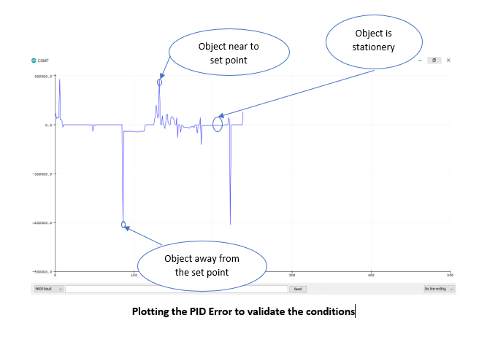
Figure 4

Discussion and Conclusion:

This project covers just a portion of a huge current research area. Currently we don’t see this technology implemented at our current local stores’ shopping carts yet. However many big robotic manufacturers and grocery stores are investing heavily into bringing these human following rovers a reality for customers. The significance of this technology can be reflected in the positive impacts that will bring to the elderly & special needs population. They will be able to go shopping without pushing heavy loads around. Oftentimes these people cannot enjoy going out shopping on their own and are forced to stay home and wait for a family member or friend to accompany them when heading to the store. They will enjoy a more pleasant shopping experience and enjoy independence when doing such activities. These ideas could also be expanded into performing military tasks as well. A rover that follows a soldier around could be of tremendous help. These rovers could free a soldiers’ hands and carry heavy loads or medical aid for them. Given this feature, it might one day prove to be a milestone in vehicle automation.

Contributions of Individual Group Members:

Arunachalam Venkatachalam (333000500) – Initial & final phases of the Robot’s assembly & circuit part. Initial, Middle & final development phases of the coding side of the robot. PID tuning. Material Purchasing. Mid Term proposal. Development of robots’ feedback section. Experimental Results. Final Report.

Padmashree Srinivasan (731007503) – Worked on initial & final phases of the Robot’s assembly. Middle & final development phases of the coding side of the robot. Material Purchasing. Final Report. Discussion & Conclusion. Development of robots’ feedback section. Experimental Results. Maintaining Lab notes. Feedback Control

Carlos Navarro Naranjo (726003363) – Worked on the initial & middle design phases of the Robot. Initial & middle development phases of the code. Mechanical Assembly and electrical circuit building of the first & middle phases of the robot. Testing the rover. Developed working plan & milestones. Material Purchasing and Electrical/Mechanical design. Final Report & AutoCAD Modeling/Drawings of the Robot. Experimental Results

